L13: Preparation Assignment Worked Solutions 221 B&C
Part I: Concepts
- What is the difference between matched pair data and independent samples?
There is no pairing between the two groups. Group 1 does not determine Group 2.
- Complete the chart below. In the left hand column fill in the names of the four quantitative hypothesis tests we have completed thus far in Unit II. (The first row is filled in for you.)
Name of Hypothesis Test | Requirements for test | Name of Distribution from which the test statistic is computed | Null Hypothesis and Possible Alternative Hypotheses
Hypothesis test for one mean—sigma known | Data are a simple random sample from the population.  The distribution of sample means is normal. | Normal distribution | $$H_{0}: μ= μ_{0}$$  $$H_{a}: μ< μ_{0}$$  $$H_{a}: μ> μ_{0}$$  $$H_{a}: μ≠ μ_{0}$$
Hypothesis test for one mean – sigma unknown | Data are a simple random sample from the population.  The distribution of sample means is normal. | T-Distribution | $$H_{0}: μ= μ_{0}$$  $$H_{a}: μ< μ_{0}$$  $$H_{a}: μ> μ_{0}$$  $$H_{a}: μ≠ μ_{0}$$
Hypothesis test for two means – paired data | Data are a simple random sample from the population.  The distribution of the differences means is normal. | T-Distribution | $$H_{o}: μ_{d}=0$$  $$H_{a}: μ_{d}≠0$$  $$H_{a}: μ_{d}<0$$  $$H_{a}: μ_{d}>0$$
Hypothesis test for two means – independent samples | Data are a simple random sample from the population.  The distribution of sample means from each group is normal. | T-Distribution | $$H_{o}: μ_{1}= μ_{2}$$  $$H_{a}: μ_{1}≠μ_{2}$$  $$H_{a}: μ_{1}<μ_{2}$$  $$H_{a}: μ_{1}>μ_{2}$$

Part II: Application
Independent Samples – One of the professors in the BYU-Idaho Math Department collected data from BYU-Idaho students to compare the mean wages of BYU-Idaho male students to BYU-Idaho female students. The students from his classes completed a survey which he then used to analyze if there is difference in these wages. (Use the Class Survey Data to complete this problem: Class Survey Data for SPSS)
- Design the Study:
- What is the research question?
Is there a difference between the mean wages of BYU-Idaho male students and female students?
- State the null and alternative hypothesis.
$${Ho: μ}_{1}= μ_{2 }$$
$$Ha: μ_{1}≠ μ_{2}$$
This is a two tailed test because the research question asks if there is a difference between the mean wages of males and females at BYU-Idaho. The keyword here is difference.

- Collect the Data:
- Describe the data collection procedures.
Students from one of the Math Department professor’s classes took a survey which asked how much they make as an hourly wage.
- Describe the Data:
- In a short paragraph use summary statistics to describe the data. After the paragraph insert an appropriate and well labeled graph to illustrate the data.
Males: $\overline{x}=11.935$, s = 10.49, n = 85
Females: $\overline{x}=9.759$, s = 3.169 , n = 91
These summary statistics are found by using SPSS commands Analyze – Descriptive Statistics – Explore. Move the variable Wage into the Dependent List box and the variable Gender into the Factor List box. Then click on OK. The students should also include two histograms here, one for men and one for women. 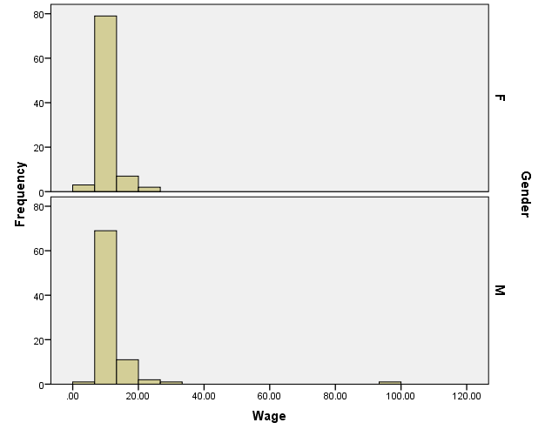
This is done by using SPSS commands Graphs – Legacy Dialogs – Histogram. Move the variable for which you want to generate a histogram into the “variable” box, in this case Wage. Then move your grouping variable into the “Rows” box, which in this case is Gender. Click on okay. This will give you a side by side histogram as the one pictured above.

- Make Inferences:
- What type of hypothesis test is appropriate?
Independent Samples Hypothesis test. Which male is chosen does not affect which female is chosen, or group one does not affect group two.
- Are the requirements met for this test? Explain.
The sample size is large for each sample so we can assume normality.
It was not a simple random sample, because it was just taken from one professor’s classes.
- Compute the test statistic.
t = ±1.836
This is done by using the SPSS commands Analyze – Compare Means – Independent Samples T-test. Move the variable that you are testing into the Test Variable box, which in this case is Wage. Then move the grouping variable to the Grouping Variable box, which in this case is Gender. Next Click on the Define Groups box and Define the Groups as M for male and F for female.

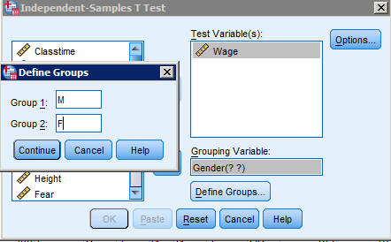
Then Click on Continue and OK. This gives you an output as the following. This is only half of it, but it contains what you need. In this course we always use the information for Equal variances not assumed.

Independent Samples Test
 |  | Levene's Test for Equality of Variances |  | t-test for Equality of Means
 |  | F | Sig. | t | df | Sig. (2-tailed) | Mean Difference | Std. Error Difference | 95% Confidence Interval of the Difference
 |  |  |  |  |  |  |  |  | Lower | Upper
Wage | Equal variances assumed | 4.204 | .042 | 1.889 | 174 | .061 | 2.17618 | 1.15206 | -.09763 | 4.44999
Wage | Equal variances not assumed |  |  | 1.836 | 98.263 | .069 | 2.17618 | 1.18544 | -.17622 | 4.52858

- State the degrees of Freedom.
df = 98.263
- Compute the P-value and compare it to the alpha level.
P-value = 0.069 α = 0.05 → p-value > alpha
- Make a decision. Do you reject the null hypothesis or fail to reject it?
Fail to reject the null hypothesis
- Present your conclusions in the form of an English statement.
We have insufficient evidence to say that there is a difference between wages of male and female BYU-Idaho students.
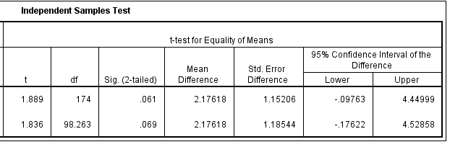
- Rather than testing a hypothesis, now say you just wanted to estimate the difference between female and male wages at the 95% confidence level. Create a confidence interval to estimate this difference.
(-0.17622, 4.52858) or (-4.52858, 0.17622)
This confidence interval is output as the test statistic and p-value. It is just further to the right on the table, which is not shown above, but is shown below. Remember to always use the bottom row of data because that is for equal variances not assumed.
- Now interpret the confidence interval you built above.
We are 95% confident that the true difference in mean wages between women and men at BYU-Idaho is somewhere between $-0.18 and $4.53 or $-4.53 and $0.18.
We can also see that there is insufficient evidence using the confidence interval method because zero is included in our confidence interval.
- Take Action
- In a short paragraph describe the action you feel should be taken based on the statistical results above.
(Answers may vary)
An example: No action needs to be taken because males and females at BYU-Idaho are making roughly the same amount of money. If there was a statistically significant difference than something would need to be done to equalize pay among male and female students.

